**WEEK 4: 2. Spring-rest-handson**

**Hello World RESTful Web Service**

Write a REST service in the spring learn application created earlier, that returns the text "Hello World!!" using Spring Web Framework.

**Code:**

**SpringLearnApplication.java**

package com.cognizant.springlearn;

import org.springframework.boot.SpringApplication;

import org.springframework.boot.autoconfigure.SpringBootApplication;

@SpringBootApplication

public class SpringLearnApplication {

public static void main(String[] args) {

SpringApplication.*run*(SpringLearnApplication.**class**, args);

}

}

**HelloController.java**

package com.cognizant.springlearn.controller;

import org.slf4j.Logger;

import org.slf4j.LoggerFactory;

import org.springframework.web.bind.annotation.GetMapping;

import org.springframework.web.bind.annotation.RestController;

@RestController

public class HelloController {

private static final Logger *LOGGER* = LoggerFactory.*getLogger*(HelloController.**class**);

@GetMapping("/hello")

public String sayHello() {

LOGGER.info("START - sayHello()");

String message = "Hello World!!";

LOGGER.info("END - sayHello()");

return message;

}

}

**application.properties**

server.port=9090

logging.level.com.cognizant.springlearn.controller=DEBUG

**pom.xml**

<project xmlns="http://maven.apache.org/POM/4.0.0"

xmlns:xsi="http://www.w3.org/2001/XMLSchema-instance"

xsi:schemaLocation="http://maven.apache.org/POM/4.0.0

http://maven.apache.org/xsd/maven-4.0.0.xsd">

<modelVersion>4.0.0</modelVersion>

<groupId>com.cognizant</groupId>

<artifactId>spring-learn</artifactId>

<version>0.0.1-SNAPSHOT</version>

<packaging>jar</packaging>

<name>spring-learn</name>

<description>Spring Learn Application</description>

<parent>

<groupId>org.springframework.boot</groupId>

<artifactId>spring-boot-starter-parent</artifactId>

<version>2.7.18</version>

<relativePath/> <!-- lookup parent from repository -->

</parent>

<properties>

<java.version>17</java.version> <!-- Change to 21 if using Java 21 -->

</properties>

<dependencies>

<dependency>

<groupId>org.springframework.boot</groupId>

<artifactId>spring-boot-starter-web</artifactId>

</dependency>

<dependency>

<groupId>org.springframework.boot</groupId>

<artifactId>spring-boot-devtools</artifactId>

<scope>runtime</scope>

<optional>true</optional>

</dependency>

<dependency>

<groupId>org.springframework.boot</groupId>

<artifactId>spring-boot-starter-logging</artifactId>

</dependency>

<dependency>

<groupId>org.springframework.boot</groupId>

<artifactId>spring-boot-starter-test</artifactId>

<scope>test</scope>

</dependency>

</dependencies>

<build>

<plugins>

<plugin>

<groupId>org.springframework.boot</groupId>

<artifactId>spring-boot-maven-plugin</artifactId>

</plugin>

</plugins>

</build>

</project>

**Output:**

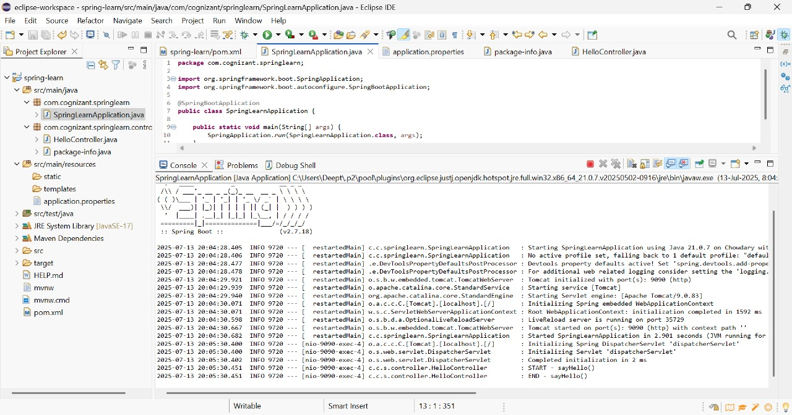

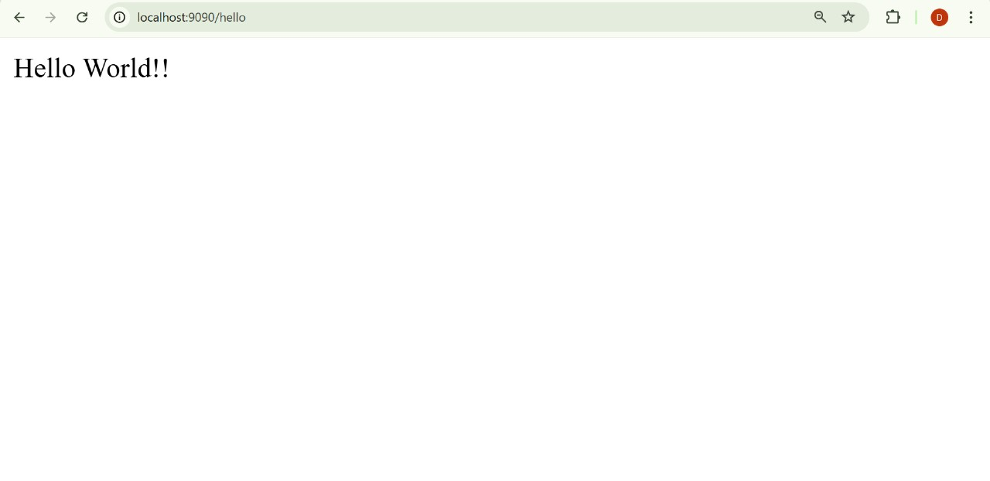

**REST - Country Web Service**

Write a REST service that returns India country details in the earlier created spring learn application.

**Code:**

**Country.java**

package com.cognizant.springlearn.model;

public class Country {

private String code;

private String name;

public Country() {}

public String getCode() {

return code;

}

public void setCode(String code) {

this.code = code;

}

public String getName() {

return name;

}

public void setName(String name) {

this.name = name;

}

}

**spring.xml**

<?xml version="1.0" encoding="UTF-8"?>

<beans xmlns="http://www.springframework.org/schema/beans"

xmlns:xsi="http://www.w3.org/2001/XMLSchema-instance"

xsi:schemaLocation="http://www.springframework.org/schema/beans

http://www.springframework.org/schema/beans/spring-beans.xsd">

<bean id="in" class="com.cognizant.springlearn.model.Country">

<property name="code" value="IN" />

<property name="name" value="India" />

</bean>

</beans>

**CountryController.java**

package com.cognizant.springlearn.controller;

import com.cognizant.springlearn.model.Country;

import org.springframework.context.ApplicationContext;

import org.springframework.context.support.ClassPathXmlApplicationContext;

import org.springframework.web.bind.annotation.RequestMapping;

import org.springframework.web.bind.annotation.RestController;

@RestController

public class CountryController {

@RequestMapping("/country")

public Country getCountryIndia() {

ApplicationContext context = new ClassPathXmlApplicationContext("spring.xml");

Country country = (Country) context.getBean("in");

return country;

}

}

**application.properties**

server.port=9090

SpringLearnApplication.java

package com.cognizant.springlearn;

import org.springframework.boot.SpringApplication;

import org.springframework.boot.autoconfigure.SpringBootApplication;

@SpringBootApplication

public class SpringLearnApplication {

public static void main(String[] args) {

SpringApplication.*run*(SpringLearnApplication.**class**, args);

}

}

**Output:**

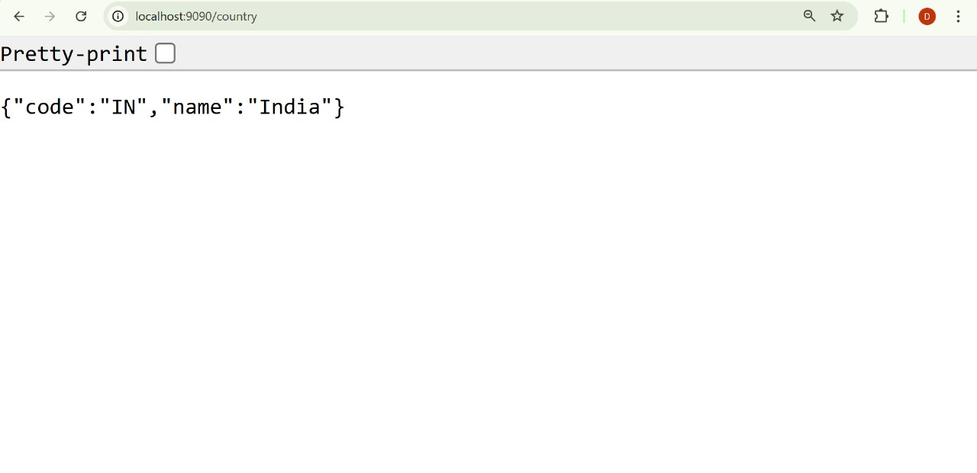

**REST - Get country based on country code**   
  
Write a REST service that returns a specific country based on country code. The country code should be case insensitive.

**Code:**

**Country.java**

package com.cognizant.springlearn.model;

public class Country {

private String code;

private String name;

public Country() {}

public Country(String code, String name) {

this.code = code;

this.name = name;

}

public String getCode() {

return code;

}

public void setCode(String code) {

this.code = code;

}

public String getName() {

return name;

}

public void setName(String name) {

this.name = name;

}

}

**CountryService.java**

package com.cognizant.springlearn.service;

import java.util.List;

import org.springframework.beans.factory.annotation.Autowired;

import org.springframework.context.ApplicationContext;

import org.springframework.stereotype.Service;

import com.cognizant.springlearn.model.Country;

@Service

public class CountryService {

@Autowired

private ApplicationContext context;

public Country getCountry(String code) {

List<Country> countries = context.getBean("countryList", List.class);

return countries.stream()

.filter(c -> c.getCode().equalsIgnoreCase(code))

.findFirst()

.orElse(null);

}

}

**CountryController.java**

package com.cognizant.springlearn.controller;

import org.springframework.beans.factory.annotation.Autowired;

import org.springframework.web.bind.annotation.*;

import com.cognizant.springlearn.model.Country;

import com.cognizant.springlearn.service.CountryService;

@RestController

public class CountryController {

@Autowired

private CountryService countryService;

@GetMapping("/countries/{code}")

public Country getCountry(@PathVariable String code) {

return countryService.getCountry(code);

}

}

**SpringLearnApplication.java**

package com.cognizant.springlearn;

import org.springframework.boot.SpringApplication;

import org.springframework.boot.autoconfigure.SpringBootApplication;

import org.springframework.context.annotation.ImportResource;

@SpringBootApplication

@ImportResource("classpath:country.xml")

public class SpringLearnApplication {

public static void main(String[] args) {

SpringApplication.run(SpringLearnApplication.class, args);

}

}

**application.properties**

server.port=8083

**Output:**

